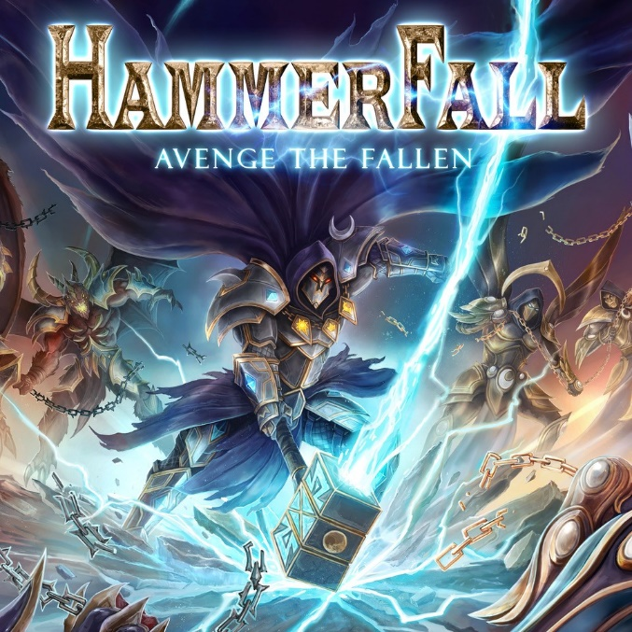

HAMMERFALL

»Avenge The Fallen«

OUT: August 9th 2024
Line up: | HAMMERFALL online:
Joacim Cans - Vocals  Oscar Dronjak - Guitar  Pontus Norgren - Guitar  Fredrik Larsson – Bass  David Wallin - Drums | www.hammerfall.net/  www.facebook.com/hammerfall  www.instagram.com/hammerfall_official/

Still on a natural high following a hugely successful two-year tour with the German metal veterans HELLOWEEN under the banner of the “United Forces” tour, that took both bands all over the world together, the award-winning Swedes HAMMERFALL are back to avenge the fallen!
“Everything is like it’s always been”, HAMMERFALL’s founder and guitarist Oscar Dronjak says with pride. He continues: “When I started HAMMERFALL more than 30 years ago it was because no one played the music that I grew up with and was a huge fan of. If no one did it, it was up to me to do it and that’s how it is still to this day. The music I write is the music that I love and believe in, heavy metal can’t be faked and that’s a fact!”
A fact as clear as ever before when HAMMERFALL gets ready to unleash their 13th album Avenge The Fallen on the 9th of August, 2024. That’s right, less than a year after taking the final bow of the “United Forces” tour the quintet of Oscar, singer Joacim Cans, bass player Fredrik Larsson, guitarist Pontus Norgen, and drummer David Wallin are back with ten brand new solid pieces of classic heavy metal.
“This is our 13th album”, Joacim says with pride. “How do you still stay relevant after 13 albums? It’s very much like the opening line to the song ‘Avenge The Fallen’: What is the worst, be the one who died, or be the one who survived. Think about it, because it is a tough question”. He continues, “Do we want to be a band who releases new music just for the sole reason of getting out on the road again or do we want to keep pushing and challenging ourselves? In times where people have less and less attention span, we still think in the form of full length albums. A few good songs don’t make a strong album. A strong album comes from an album full a great songs and that’s what we’re delivering with Avenge The Fallen.”
“We are in a fortunate position where we nowadays actually can compose while being on tour”, Oscar explains. “That’s something that would have been impossible just ten years ago. In many ways I even think this album benefited from getting off stage somewhere in Germany and then heading straight to the tour bus, where we had a small studio set up in the back lounge. By doing so we were still oozing adrenaline when the new material was crafted.”
That’s something that easily can be heard in the heavy opener ‘Avenge The Fallen’ a song that will surprise fans in many ways and immediately grab their attention, while the follower ´The End Justifies´ is classic HAMMERFALL in every sense possible. A song destined for glory.
“I am in a much more confident mood than before”, Oscar continues. “In the past I wrote what was needed for an album and then I didn’t write anything more. Nowadays I have no problems writing songs and then keeping them until later albums where I know that they will get the right attention. Call it confident, call it maturing, I don’t know what it is, but ever since I turned 40, I’ve learned to not dive headfirst into everything.”
While many of the songs on Avenge The Fallen were crafted on the road, there’s also songs from the album based upon ideas spawned as far back as 20 years prior. The beautiful ballad ´Hope Springs Eternal´ being one of those ideas and a perfect example of the creativeness between Oscar and Joacim, who all these years later, continue to keep inspiring each other while crafting new music.
“I’ve had this idea for a ballad waiting to come alive for a long time, but it just wasn’t there”, Oscar explains. “I just couldn’t get it right, then as soon as Joacim had a look at it, he knew exactly what was missing.”
It’s this kinship and musical connection that is the real secret weapon to the success of HAMMERFALL.
“The way we build the melodies for the verses, the pre choruses and the bridges; The crafting of new songs.... that’s what makes us such a strong team and what’s carried HAMMERFALL ever since he set foot in our old rehearsal room!” Oscar continues.
One of the songs that was born on the road was the album’s first single and video ´Hail To The King´. “I began working on ´Hail To The King´ while on tour in the US with HELLOWEEN”, Oscar recalls. “By the end of the tour, I was getting close to wrapping the song up so straight after the Los Angeles gig I headed to the bus where I worked like a mad man to get the last pieces together. That turned out to be the show where one of my favourite wrestlers, Chris Jericho, came to visit. It was also the show where Fredrik met his idol Frank Bello from Anthrax and Joacim met Jay Ruston, producer for Armored Saints, Avatar, Anthrax, Corey Taylor and more and whom after this meeting agreed to produce the vocals for ´Avenge The Fallen´! I missed all that, but I at least got a great song out of it, haha!”
Joacim adds, “Working with Jay on this album was a great challenge. After doing the vocals for our previous album Hammer Of Dawn in Denmark together with producer Jacob Hansen (Pretty Maids, Amaranthe etc), I couldn’t wait to get back to Los Angeles to work. I’m one of those people who likes to have it good in life. I mean, who doesn’t. It’s a city that never fails to inspire me. I’d been working tirelessly together with Oscar for the better part of a year creating the songs that would become Avenge The Fallen and thanks to that plus being on the road as much as we’ve been these past years, has really helped keep both me and my voice in great shape and the result I feel is one of my best performances on an album ever.”
While in the Los Angeles’ in the hands of the producer Jay, HAMMERFALL also found themselves with a star-studded team on backing vocals for ‘Avenge The Fallen’.
“Besides our fellow Swedes: Thomas Vikström (Therion), Jake E (Cyhra) and Niklas Isfeldt (Dream Evil) who recorded their parts in Sweden, we found ourselves sitting in the studio in USA together with none other than the powerhouses, John Bush (Armored Saint, ex-Anthrax) and Marc Lopez (Metal Church)”. Joacim continues. “We’ve always had good singers doing backup vocals on our albums, but this is something completely different for HAMMERFALL. It’s thanks to this high calibre of collaborators on the album, that we’ve been able to meet the challenge of overcoming the most demanding back- up vocals we’ve ever had while achieving the best results.“
The music from the album was recorded in Sweden by HAMMERFALL guitarist Pontus and mixed by Fredrik Nordström at Studio Fredman, once again co creating a true and genuine HAMMERFALL sound that the fans have come to love.
When it comes to the main focus of the album Joacim mentions ‘freedom’ and the urge to let anyone be who they want to be. It’s represented in the albums cover, where the bands faithful warrior Hector choses to walk his own path, despite what others tell him to do. Much like HAMMERFALL have and always will do.

